Agile Business Analysis

Requirements and Management Folio of Work

Project: Sam *Chat Bot* *Griffith University*

Author: Yasin Çakar

S Number: s2921450

Workshop: Friday, 8 AM, Brodie Greig

Table of Contents

Introduction 3

Purpose of this Document 3

Scope of this document 3

Background 5

Business Goals 5

Agile Approach 6

Stakeholders 6

Stakeholder Definition 8

Stakeholder Communication 10

Product Vision 11

Requirements 15

Delivery and Review 19

Project Management 19

APM Framework 19

# Introduction

## Purpose of this Document

The purpose of this document is to explore the requirements, define the scope and initiate further research into the development of the Sam chat bot project which was closed on September of 2017. This document intends to establish the foundation for developing a software solution for the above mentioned project to adequately meet key stakeholder expectations. The system to be developed is the proposed Sam Chat Bot which resolves queries of staff students, visitors and aspiring student via text prompts into the chat box system, in real time. Griffith University aims to recommence this project in partnership with Microsoft along with the assistance of its industry partners. This project endeavor not only provides service to Griffith university stakeholders but also allow the university to conduct further research in the field of artificial intelligence. The main focus of this document is to outline the agile development practices that will be considered in developing the chat bot system. This document breaks down the development project into various phases of the agile development framework, this document explores design decisions, stakeholder communication and engagement as well as validation and verification procedures before the handover of the final product to the project owner.

## Scope of this document

## 

This document investigates the requirements and management that comprise the basis of developing the Sam chat bot software system using the agile approach. The agile approach is most effective with modern software development in order to elicit stakeholder requirements that deliver user scenarios that meet (or even exceed) user expectations. Software development is a new field in science and technology with respect to other fields, unlike other scientific disciplines, software development is not tangible, and it is more malleable and dynamic in nature [1]. The agile framework is most feasible as it ensures customer satisfaction as it is an interactive approach with client feedback and team based method that aims to deliver a software solution in a shorter amount of time.[2]

There are several agile approaches in developing a software product, this document will discuss the chosen approach and its analysis.

The key components of this document include the product vision which is to be met by finding a fit with key stakeholders and the business goals by satisfying stakeholder requirements effectively with respect to the schedule, time and budget of the project.

The development and delivery of the chat box software system strategy will be thoroughly explored in this document by integrating analysis of stakeholders, product vision, requirements, agile approach, business goals and project management approach. In order to develop a successful product it is necessary to identify the target audience, which is the stakeholder(s). Understanding stakeholder requirements will assist in understanding of the product vision that the performing organisation has to define the deliverable, the deliverables of the product vision is developed using the chosen agile approach that will realise the business goals. Efforts to develop and deliver the objectives of the business goals are delivered via a suitable project management approach.

This document will not deal with change requests or additional features apart from the requirements covered in this document nor will it cover marketing of the chat bot project, this document is to assist the product development as a high level technical analysis.

Project Scope

|  |  |  |  |
| --- | --- | --- | --- |
| Project Name | Sam Chat Bot | | |
| Project Sponsor | Griffith University | Project Manager | Yasin Çakar |
| Date of Project Approval | In progress | Last Revision Date | In progress |
| Scope Description | IN SCOPE   * “A Chat Bot released which can help commencing students to solve common IT and non-IT queries 24 hours a day, released into production. * A personality for the Bot which both appeal to users and aligns to Griffith’s personality. * An operational support model which ensures the Bot is properly supported after the project without adding unnecessary costs. * An integrated support and governance structure which can guide the future direction of the new service.”   OUT OF SCOPE   * Updating of knowledge base articles in Ask Us or Cherwell. * Developing further intents other than the General one. * Developing further canvases (communication platforms). * Launching the Bot on platform other than the Griffith website. * Promoting the Bot for continuing students. * Promoting the Bot for staff. | | |
| Project Deliverables | * Cognitive computing system to process natural language * Cognitive computing system that computes missing data by deriving from other records to populate the database for future enquiries. * Easy to follow user interface. | | |
| Acceptance Criteria | The project will be accepted when it is agreed by the Griffith Executive Committee that the deliverables meet their needs (deliverables signed off). The project will be considered a success if post launch user surveys shows that user satisfaction is 3.5 points out of five. | | |
| Constraints | The Griffith Executive Committee Representative is the only dedicated member to this project as the project owner in the Scrum team. | | |
| Assumptions | The Griffith Executive Committee Representative will be in touch with Senior Management of Griffith university, Griffith Executive Committee and the Griffith Development team to relay any necessary feedback to the Scrum master who is the project manager | | |

## Background

Cognitive Computing (CC) is a software paradigm that is based on scientific disciplines of artificial intelligence and signal (or data) processing [3], at present there is no widely agreed definition on cognitive computing. This software platform is a new paradigm that takes automation of technology to a new level, this means cognitive learning systems imitate the human brain, with teaching itself, independent reasoning and problem solving as well as processing natural language capabilities.

Griffith university intends to explore this new technological trend to offer a unique solution to a common age old problem, that is seeking to resolve enquires at a convenient time accurate e and consistently with minimum waiting time to acquire the required information.

Griffith university had initiated the first phase of this endeavour which this project closed in September 2017. As the first phase project was restricted to solving basic queries, this phase provided a platform to investigate into cognitive computing. The first phase included IT queries that include password resets, printing issues and Wi-Fi connection issues. However this first phase is a simpler system compared to cognitive computing whereby instead of processing high level human language for data mining, this system relies on a simpler system that scans for keywords within the input, then pull a reply with the most matching keywords, or the most similar wording pattern, from a database.

Phase two anticipates further development whereby the chat bot resolves user enquires using independent decision making algorithms allow the chat bot systematically learn new information and teach itself to better fulfil the unpredictable narratives of student and staff enquiries.

A chat bot is a computer program or artificial intelligence software that can hold a conversations via auditory or textual means in a capacity to pass turing tests. Implementing a revised system that combines this capacity with cognitive computing will render this product a significant gain creator as well as a pain reliever.

# Business Goals

The objective of this project is to promote the chat bot project and achieve client satisfaction by addressing stakeholder requirements and implementing feedback into design procedures. Achievement of business goals will be measured by the results of the beta trial of the first release of the second phase.

This project is aimed at reflecting gain creators in the following fields, marketing, Griffith University goodwill, promoting industry partnerships, increasing university process performance, financial benefits to the university, statistical and research capacity for the university as well as academic results for senior students involved in this project.

The introduction of the project is to provide maximum gain creators and pain relievers to the client Griffith university, and thus indicate project success.

The new chat box will be more interactive, smart and even charismatic, the presence of interactive artificial intelligence will be a great marketing pull-factor for aspiring university students. Future students can use the chat box to enquire about OP requirements and entry positions to the Sam chat system. This new feature will add a goodwill to the university’s reputation.

The universities goodwill will be reinforced as students and staff can receive accurate and consistent information at their convenience available 24 hours for seven days of the week.

Another indicator of achieving business goals is promoting industry partnerships. The Sam chat bot will attract industry partners as well as deepen the partnership Griffith University has with Microsoft.

Having the workload of attending staff and student enquiries being handled by this software systems means university staff that used to attend queries for student or client support can focus on other tasks increasing overall workflow throughput. At the same time when the chat bot is available to course related queries academics can focus more on research and course material preparation.

The financial payoff the chat box will offer besides being a marketing and goodwill asset includes allocating funds to research and infrastructure that were previously used for student support staff.

One of the most important gain creators of this product will be the increased capacity in statistics and research. Data mining the chat bot can be used to garner statistical information that can assist the university in it future projects.

The final benefit will be the involvement of Griffith university students to work on this new system such as master and PhD students for their industrial training and development during the development phase of this project.

The project in phase two is very promising in terms of achieving business goals if each sprint of the development cycle is well planned and contingency reserves are made for unforeseen spikes.

## Agile Approach

In the modern day software market, the key to having an edge in software development and marketing boils down to two main points that is adaptability to change and time-to-market. The only way to achieve this is to have an interactive and team based development method that aims to deliver an application in a short period of time. For such a method to be successful in delivering software products with tangible value propositions in a relatively short period of time requires such method to be ‘Agile’. The Agile approach is as its name suggest an agile method in developing software solutions, meaning that the Agile development approach is innovative and iterative while made up of a self-organised team. This is true as Agile is an approach rather than a set of series of steps or processes, unlike traditional development methods. The agile methods has an adaptive culture that is based on principles of self-organisation and self-discipline rather than traditionally structured, authoritarian development methods. This allows to develop products that meet stakeholder needs as specifications in agile focus on the benefit to the user rather than traditional approaches that focus on inputs, outputs and processing.

The approach chosen to develop the Sam chat box is to use Scrum in combination with Kanban.

Scrum is an incremental and iterative agile approach that plans frequent regular releases of product deliverables according to the customer requirements, time constraints, competition, quality, vision and available resources.

The Scrum flavour of Agile was chosen for this project as it provides the structure for organising feedback, short term planning, stack ranking and an inspect an adapt mindset as well as other organisational improvements.

A scrum project begins with the scrum team and the product owner writing everything they can think of that describes the items and features desired to be present in the final product, these features may include the complete feature set of the final deliverable or contain enough for the first sprint and be elaborated after each product increment.

After the product backlog is complete, the product owner is present at the sprint planning meeting with the prioritised agile product backlog. In this project the method for this is to go through a product backlog refinement phase before all the user stories in the backlog are organised according to it priority in a Story map, each release in the story map will correspond to a sprint. After the meeting with the product owner in beginning of each sprint, the items are moved from the product backlog to the sprint backlog. By expanding each product backlog item into one or more sprint backlogs the development items can be easily delegated managed and controlled. In the case of this folio the story map can be edited and updated if circumstances change or time and resources permit additions to the incremental product as the Scrum master receives feedback from the project owner.

After the product backlog and the sprint backlog is prepared, the software development using sprints begin. A scrum project progresses via a series of sprints, these development periods are time boxed to no more than a month and most commonly are two weeks in duration. A daily scrum meeting is held on each day of the sprint, these meetings are time boxed to no more than 15 minutes to establish work completed on the previous day and identify any hindrance to the development.

Scrum is the ideal agile approach as it relies on self-organising, cross-functional teams, therefore there is no overall team leader who decides which person will do which task or how a problem will be solved, they are decided by the team as a whole. Rather than the project being driven by external processes and controls scrum ensures the product is being developed according to requirements specified in the perspective of the user using the available resources. More over as the scrum approach is composed of a series of sprints this is ideal to dedicate sprints for when there is unexpected spikes in the project. Spikes are unexpected problems that occur in the middle of a sprint, these can occur due to a number of reasons, such as new technologies, functionalities delivered in an ambiguous way and so forth.

The other agile technique that will be used in combination with the Scrum is Kanban. Kanban is said to be lean scheduling system developed in Japan by the Toyota Motor Corporation. A Kanban system utilises visual cues that tell the development team what to produce when to produce, how much to produce. Kanban provides a streamlined flow of tasks that reach one hundred percent completion by helping the development team manage day-to-day development with minimum overhead and hindering issues.

In order to assist the completion of development items at a steady pace, Kanban imposes limits on the number of items that can live in any work flow step at any given time, these limits are called Work In Progress (WIP) limits, set so that the work flows as smoothly and consistently as possible. This way if the team runs into a problem of not keeping up with finishing tasks before other items are added, this will create a visible bottleneck and ensure the team collaborates to resolve any latency in the completion of task.

As mentioned Kanban focuses solely on the development of products by moving items from a backlog to intermediary work flow steps up to completion. For this reason implementing the Kanban as a tool during the sprints should assist in ensuring that the team efficiently keep up with work flow, save time by eliminating too much task switching and thus ensuring timely completion of tasks.

# Stakeholders

## Stakeholder Definition

Identifying key stakeholders that have influence is foremost in any given project. As the requirements are documented in the form of user stories, which is a list of functionality and attributes in the viewpoint of the end stakeholder. Particularly when using the scrum agile approach, the stakeholder is an important part of the development process as each meeting in the beginning of each sprint requires interaction between the scrum master, scrum team and the project owner.

Stakeholders are an integral part to the agile development project as stakeholder requirements are the basis of supporting business goals as well as a means of marketing and promoting a project. Stakeholder requirements form the business goal, the business goal defines a project’s long term target and this is used to define short term objectives.

Identifying stakeholders as early as possible is critical as stakeholders are people who are either involved with or affected by the project in some way. Some stakeholders may present opportunities while others pose threats.

The stakeholders that can greatly influence the outcome of a project are known as the key stakeholders, these are the stakeholders that need to be managed closely as they are in a position to influence a project either positively or negatively.

The most important aspect in dealing with stakeholders is managing stakeholder expectations. This aspect needs to be dealt with in the earliest phases of the project, to establish an efficient solution to achieving the business goal(s) and fulfilling the product vision. The project manager and the performing organisation needs to be clear about what can and cannot be delivered in a project, and what can and cannot be achieved. These need to be communicated to the stakeholder as earliest as possible as it will influence stakeholder satisfaction with the end product.

The aim of this scrum project is to establish stakeholder expectations as early as possible and to reinforce and support this through each iteration of the project via the numerous sprints to support a common expectation between the stakeholder within the scrum team as well as stakeholders external to the scrum team to have a common expectation of the final product outcome.

The identified stakeholders are categorised into two groups, the Scrum team and stakeholders external to the team. The scrum team consists of the Scrum master (who is also the project manager), product owner and the development team. The development team includes the developers, Quality assurance engineer, system architect, business analyst and the testers. The stakeholders external to the team consists of the Griffith executive committee, Griffith development team, the sponsors, marketing and sales department, senior management and the end users of the chat bot system.

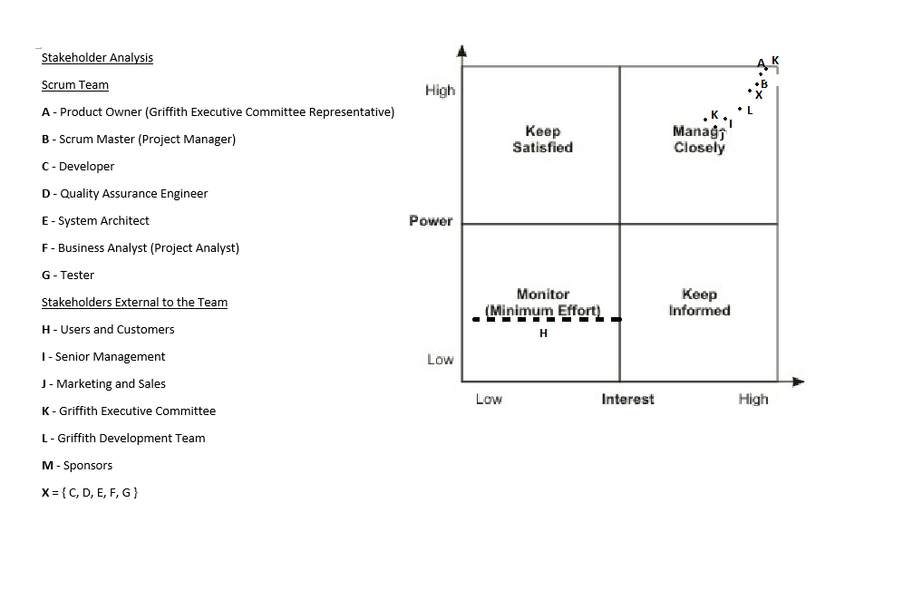

The power vs. interest grid above summarises the various stakeholders and their potential to influence the workflow and the outcome of the project. The grid above is not only a guide with respect to the position of power and interest of the stakeholders, but also an important tool in mapping the influence each stakeholder has with respect to other stakeholders.

The stakeholders with the greatest influence is the Griffith Executive Committee, they initiate the project and follow up on progress made on the prject via their representative who is also the project owner in the context of the scrum development team. The committee has the most interest after the scrum master (the project manager) and the development team as they want a product that fulfils the needs of the university. For a successful project the development team need to develop a product that satisfy the functionality required by the university’s executive committee, the gain creators of this product should add gains to the university’s business workflow, the convenience provided by the end product should also offer pain relievers that eliminate matters that would have previously caused inconvenience to the universities workflow.

The stakeholder with the second greatest interest in the project is the project owner as this persons job is to laisse both the scrum development team as well as the Griffith executive committee. The product owner is one of the key stakeholders, part of the product owner’s responsibility is to have a vision of what needs to be developed. As the product owner is the representative of the executive committee, he/she has an all-round understanding of what the client organisation needs. The product owner uses this understanding by participating in the development of the product backlog with the scrum master. The product owner in this project is not the lead user of the system but knows the value the product will provide to the university. The product owner is a pivotal part of the stakeholder communication process as this is the person who has a vision for what needs to be developed.

The most influential stakeholder in the scrum team is the scrum master. The scrum master is the project manager in this project, hence a key stakeholder. The scrum master uses technical, organisational as well as communication and interpersonal skills to manage the project from start to completion. The scrum master is the next influential stakeholder after the above mentioned stakeholders, this person is responsible for utilising a combination of skills such as Communication, People Skills, Leadership Skills, Relationships and networks, and Political Skills along with Problem Solving Skills, Subject Matter Knowledge, Presentation Skills, Knowledge of Project Management Tools, Organisational Skills, and Life Cycle and Process Skills.

The end users, who are university students and staff have the least power on the project as the development of this project guaranteed is almost certainty to attract end users to using the developed system. The interest of the end users has been assumed as low to moderate until the system is developed and released.

## Stakeholder Communication

The key to successful stakeholder management is good communications, communication is the art of getting the right information, to the right people, at the right time. The style and medium required for communication is also context dependent, therefore communication is both an art and a technical skill, effective communication between the scrum team and external stakeholders is necessary to establish a common understanding of the product vision, it is important to understand what is expressed and not what is thought to have/should be expressed. Communication among the external stakeholders and among the scrum development team members is also important for effective team work.

The management of stakeholder communications require an extensive skillset, it is important to be able to express yourself, your needs and understand others as they intended to be understood. In order to facilitate this, a stakeholder communication plan has been developed as follows:

|  |  |
| --- | --- |
| **Code** | **Reference** |
| **IN** | Internal to the Scrum team |
| **EX** | External to the Scrum team |

|  |  |  |  |  |  |  |  |
| --- | --- | --- | --- | --- | --- | --- | --- |
| No | Stakeholder | IN / EX | Communicates with | Communication method | Frequency | Communication Content | Expectations/ requirement |
| 1 | Scrum Master  (Project Manager) | IN | Product Owner  Scrum Team | Email, meetings, phone, in person  Project Reports  Email, meetings, phone, in person | Start of Project  End of Project  Each sprint  Daily basis | Project progress  Development requirements, scheduling, deadlines and feedback | Completion of project, within budget, on time |
| 2 | Product Owner  (Griffith Executive Committee representative) | IN | Scrum Master | Email, meetings, phone, in person | Start of Project  End of Project  Each sprint | Project progress | Completion of project, within budget, on time.  Project initiation, specification of product requirements and standards  Project execution, Technical assistance  Faults & updates |
| 3 | Developers  (Scrum Team) | IN | Scrum Master | Email, meetings, phone, in person | Daily basis | Jobs Completed, potential risks/opportunities.  Status updates. | Sprint objectives |
| 4 | Quality Assurance Engineer  (Scrum Team) | IN | Developers, Programmers & Scrum Master | Email, meetings, phone, in person | Daily  Weekly | Reports, Assessments & feedback | Project development, required functionality, compliance to quality standards |
| 5 | System Architect  (Scrum Team) | IN | Developers, Programmers & Scrum Master | Email, meetings, phone, in person | Daily  Weekly | Reports, Assessments & feedback. | System architecture, system requirements, compliance to specified architectures, test cases. |
| 6 | Business Analyst  (Scrum Team) | IN | Developers, Programmers & Scrum Master | Email, meetings, phone, in person | Daily  Weekly | Progress reports, consumer & market analysis, compliance reports. | specification of product requirements and business needs |
| 7 | Testers  (Scrum Team) | IN | Developers, Programmers & Scrum Master | Email, meetings, phone, in person | Daily basis  End of each sprint | Test case specifications.  Test results.  Recommendations | Specification of product requirements and standards |
| 8 | End Users | EX | N/A | Surveys, Student feedback | End of trimester | Observations, feedback | Product usability |
| 9 | Senior Management | EX | Griffith Executive Committee  Product Owner  (Griffith Executive Committee representative) | Email, meetings, phone | At agreed dates | Project updates | Progress reports |
| 10 | Marketing and Sales | EX | Griffith Executive Committee  Product Owner  (Griffith Executive Committee representative) | Email, meetings, phone | At agreed dates | Budget updates | Budget reports |
| 11 | Griffith Executive Committee | EX | Product Owner  (Griffith Executive Committee representative)  Senior Management  Marketing and Sales  Scrum Master | Email, meetings, phone | At agreed dates | Project progress, Project changes, Project baselines. | Notified of critical updates and changes |
| 12 | Griffith Development team | EX | Product Owner  (Griffith Executive Committee representative)  Griffith Executive Committee  Scrum Master | Email, meetings, phone | End of each Sprint | Project progress, product updates | Assist with business decisions, monitor project progress, ensure product compatibility |
| 13 | Sponsors | EX | Product Owner  (Griffith Executive Committee representative)  Griffith Executive Committee | Email, meetings | At agreed dates | Project progress, Project changes, budget report. | Completion of project, within budget, on time |

# Product Vision

This section describes the product vision, the product vision is a clear convincing statement of what the project outcome is aimed to be. It is a statement designed to inspire the development team and the stakeholders to be committed to the project. The product vision intends to guide all stakeholders involved in making this project a success, the statement answers “why” the development of the product is important but does not address “how” it will be achieved.

**For**: Griffith University

**Who**: Is seeking to help students with common IT and other enquiries effectively

**The**: Sam Chat Bot

**Is a**: Cognitive Computing software system

**That**: Assist Griffith university students & staff in an interactive manner in natural language.

**Unlike**: Assistance provided to students using traditional methods, the chat bot is available 24 hours, 7 days a week from anywhere that has an internet connection.

**Our Product**: Will solve student queries quicker by:

Utilising the latest cognitive system algorithms to generate results and store in a central database.

Generate statistics for research and administrative purposes using data input (i.e: user queries)

Free up staffing time and wages spent on resolving student and staff queries.

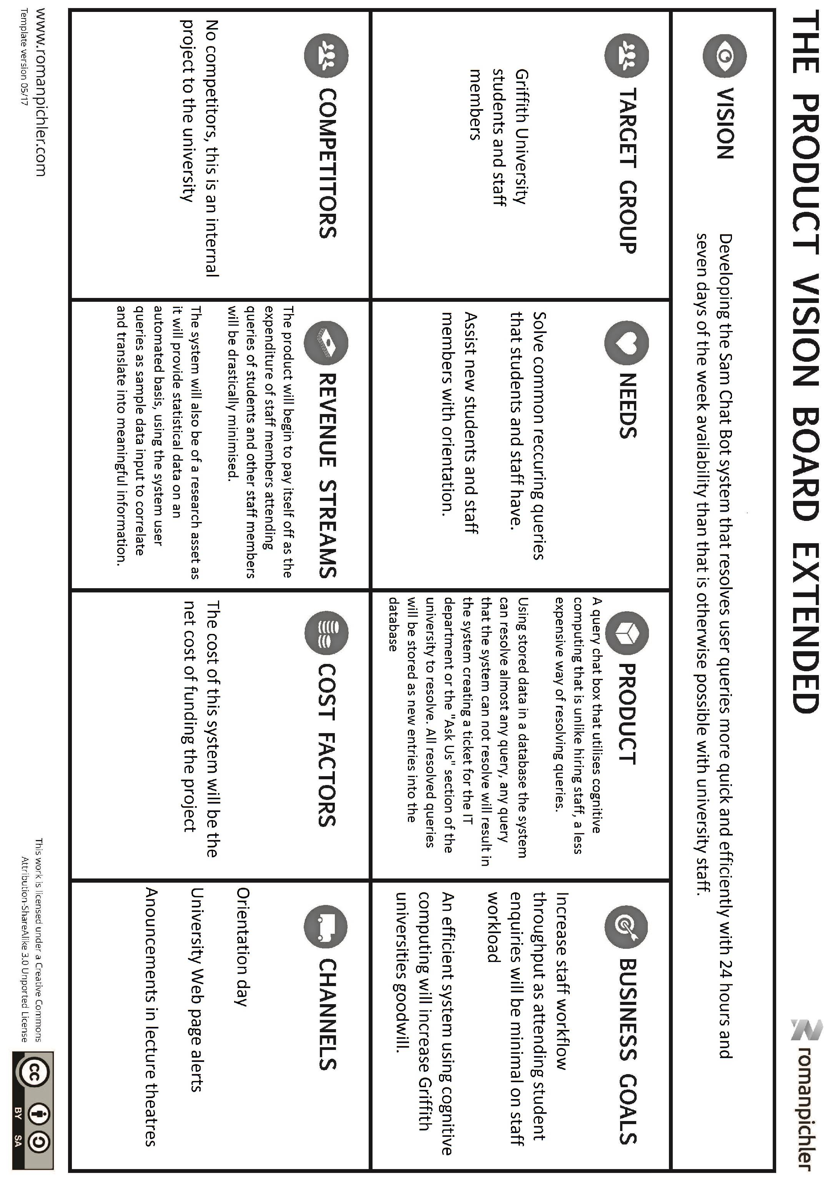

# Requirements

The requirements for the Sam Chat Bot system have been defined using a three step process. Initially all the requirements were brainstormed and put into an initial story backlog, all the items in the initial backlog were mapped on a story decomposition diagram. This diagram assisted in producing a refined scrum backlog where the elements of the highest priority are placed at the top of the list. This means elements on the top of the backlog need to be addressed first in the initial sprints of the development.

All the user story items in the table below can also be found in the story decomposition diagram:

|  |  |  |  |  |  |  |
| --- | --- | --- | --- | --- | --- | --- |
| ID | Item | | | | | Status |
| As a… | I want to be able to… | So that… | Priority | Sprint |
| P-001 | University | Have the Sam chat box system to have Natural Language Processing (NLP) capacity | users can use voice and text inputs | 1 | 1 | To be Started |
| P-002 | University | have the Sam chat box to be an independent self-learning system | It can anticipate new problems and model possible solutions | 2 | 3 | To be Started |
| P-003 | University | have the Sam chat box to generate statistical information from data provided through queries | It may assist the university in improving its services and facilities | 3 | 3 | To be Started |
| U-001 | user | access the university chat bot anywhere across Australia with consistent network speed. | I can query the chat bot | 4 | 1 | To be Started |
| U-002 | user | be able to access the Sam chat box anytime during the day with 24/7 availability. | I can query the chat bot any time | 5 | 1 | To be Started |
| U-016 | user | the Sam chat box to be platform independent and accessible using any browser. | I can access the chat bot on any device and operating system. | 6 | TBA | To be Started |
| U-006 | user | make text and/or voice queries to the chat box. | I can query the chat bot without any necessary skill. | 7 | TBA | To be Started |
| U-005 | user | ask general enquiries to the chat box rather than department personnel (eg: student services) | I may avoid travelling and waiting times. | 8 | TBA | To be Started |
| U-011 | user | query important dates (eg: last day to add a course, thecensus date). | I am up to date with the university. | 9 | TBA | To be Started |
| U-003 | Internal user | to set up, update and edit my voice signature and/or text password for the chat bot system | I can enquire personal detail related to my enrolment or employment. | 10 | TBA | To be Started |
| U-004 | Internal user | to make enquiries relating to my account and enrolment using my voice signature or chat bot password token. | Only I have access to my confidential details. | 11 | TBA | To be Started |
| U-014 | Internal user | ask complex administrative questions (eg: “do I have the prerequisites for 1234ICT”) | I can manage my studies better | 12 | TBA | To be Started |
| U-013 | Internal user | make course related queries eg. Ask assessment deadlines. | I can conveniently get quick answers on critical matters. | 13 | TBA | To be Started |
| U-010 | Internal user | query the library for resources and make reservations. | I can make reservations anywhere and any time. | 14 | TBA | To be Started |
| U-008 | Internal user | make account enquiries, such as internet quota, parking permit expiry date, printing credit and etc | I can conveniently manage my university resources. | 15 | TBA | To be Started |
| U-007 | Internal user | to start applications on the chat box using my unique identifier, for applications that need to be completed on campus (eg: showing personal identification documents), I want the chat box to give me a reference number to refer to the partial application. | I can Carry out applications with convenience. | 16 | TBA | To be Started |
| U-009 | Internal user | As an internal user I want to be able to update my accounts for example top up my balance for internet quota, parking permit expiry date, printing credit ,gym and etc. | I may follow up my campus life accounts with convenience. | 17 | TBA | To be Started |
| U-012 | Internal user | make timetabling and course queries, such as tutorials scheduled on a public holiday. | I can rely on the chat bot rather than a person to get back to me on queries. | 18 | TBA | To be Started |
| U-015 | Internal user | ask course/appointment related queries. (eg: Student- “When is my lab for 1234ICT”, Staff-“When has the meeting for xyz been postponed to?”) |  | 19 | TBA | To be Started |
|  |  |  |  |  |  |  |
|  |  |  |  |  |  |  |

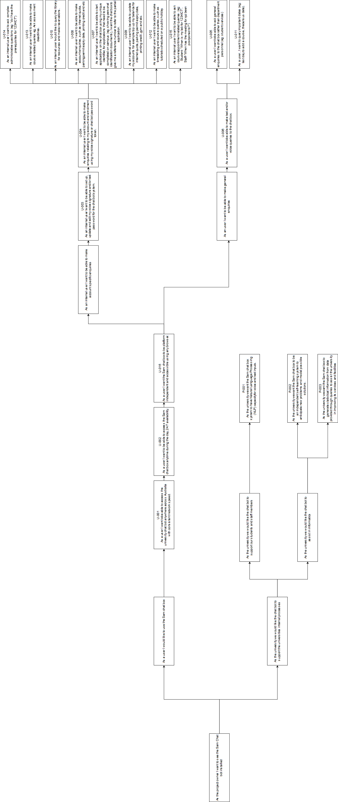

# Delivery and Review

Describe your process for maintaining and developing your requirements as the project progresses to delivery of product increments. What tools will you use? Relate these specifically to your previous sections.

The Tools to be used for delivery and review will be emphasized in *italics*.

Before the delivery and review phase is reached is important that the Strategy and Initiative horizons are solid. This means that the Strategy horizon is geared towards satisfying business goals, that is focusing on gain creators for the university such as the University Goodwill, promoting industry partnerships (i.e. Microsoft and Squiz), increasing university process performance by decreasing traditional workload of attending student and staff queries, providing financial benefits to the university and enhancing the universities statistics and research capacity. The other objective is to satisfy the vision statement and continually emphasis it to keep stakeholders united in the project endeavor.

In other words the release in the delivery horizon must align to strategic goals and initiatives.

The initiative horizon must have a solid basis, however it can be reviewed and adjusted as a result of the delivery and review in the delivery horizon as the Agile approach is known for dealing with change and continually addressing risks.

The Delivery and review has to aspects. The delivery component that is “are we delivering the right product” and secondly, “is the product delivered on time”. The review aspect considered “have we delivered the product correctly” involves insuring the test conditions are satisfied and that the team has delivered a product that aligns with stakeholder expectation.

1. Delivery
2. Has the right product been delivered?
3. Is the product delivered on time?
4. Review
5. Has the product been delivered correctly?

The above case is a crucial consideration in Agile practice as the focus in agile is functioning in self organizing, cross-functional teams as opposed to traditional waterfall driven methods that are driven by an external process.

In order to meet the criteria above it is important to execute the following steps as agile project members: Problem definition, Solution exploration and Facilitation.

The process of problem definition begins with an initial meeting between the product owner the scrum master and the business analyst. The complete picture for the problem or the search fo a solution is worked out through starting with user stories being specified then priorities with dependencies and relation being mapped, or staring with a story decomposition and decomposing the bigger picture into smaller user stories. This depends whether the tem would like to work on a top-down or a bottom up basis. All user stories must be in the perspective of the project owner and must be presented via or in consultation with the business analyst.

The solution exploration is crucial as agile is about saving process time by employing a capable self-organizing team working based on requirements and available resources rather than predefined procedures as done in traditional projects. In order to facilitate this the scrum team will be best prepared using real option, relative estimation, or consulting with external contractors such as SquizMatrix.

Facilitation can begin once the problem definition and solution exploration has been completed. After the initial meeting between the project owner, scrum master and the business analyst all of the objectives mentioned need to be facilitated using solution tools that will be discussed as well as touching on these topics at every initial sprint meeting as well as the daily stand up.

Addressing the question of a(i)”Has the right product been delivered ?” entails considering the three scenarios: Seeing the whole, Think as a customer and understand what is doable.

The first part of seeing the whole has a heavy emphasis on the business analyst’s role, they need to be present in initial meetings with the customer and in the workshop to laisse the team to develop in alignment with customer needs and expectations.

In order to deliver the right product the team must satisfy the following elements of the delivery horizon:

Element 1 - User stories ready to implement.

Element 2 - Maintain the backlog.

Element 3 - Supporting successful delivery.

Element 4 – Ensuring Learning.

Element 5 – Maintaining Focus on the Vision, Customer and Value.

Elements one and two can be satisfied using user stories and story decomposition that are then put into a story map to group with respect to the each release that corresponds to a sprint. As the project progresses the team must review the product backlog after the completion of each sprint and reflect the adjustments accordingly in the upcoming sprints. Making sure items in the product backlog are also present in the Story Map.

Elements three and four is best satisfied using a Kanban within each scrum sprint as stated in the “Agile Approach” section above. This approach ensures that all tasks can be delegated to team members, less task switching and the advent of approaching a work in progress (WIP) limit will assist in clearing roadblocks and assist the team in learning (i.e. element 4) to improve the teams understanding and thus improve team velocity.

The fifth element can be addressed by having the business analyst (BA) as the representative of the project owner within the team, this person with the responsibility of synthesizing the technical and consumer mindset and aligning it with the shared goal of the business and the product vision. The BA must facilitate meetings during the commencing of the scrum project, at the beginning of each sprint and implement inspections of the acceptance criteria and tasks delivered on story elaboration cards meet with stakeholder expectation, as well as maintain synergy within the scrum team and between the project team and the client.

The second point concerning “Is the product delivered on time”. As agile development has a focus on change and responding to change the niche capacity of agile is to deliver the minimum yet most viable product possible that satisfies quality, value, as well as budget and scope constraints. Providing the optimum solution in a timely manner requires keeping on schedule when releasing a satisfactory deliverable.

As the agile approach by its nature is concerned with detail planning for the short term and very high level planning for the short term. It is necessary to establish the total time required to fulfill and integrated and tested shippable product that fulfils all the element on the product backlog. The suitable tools for this application include real options, relative estimations outsourcing consultants and/or using these in conjunction with planning workshops. The same tools can be used if the deadline is set by and external organization, in this case these tools will be required to estimate the compromises in the other aspects mentioned above.

Once the time frames have been elicited, the focus of each sprint with respect to timely delivery will be to eliminate time wasted using a central Kanban where the whole team can view to maintain an efficient velocity.

The team must also streamline documentation using automated tools for integration testing and regression testing.

The final aspect of this section is “Has the product been delivered correctly?”. Ensuring that the product has been delivered according to specification is an ongoing endeavor of the development team. Satisfying this aspect requires Integration and regression and quality testing in each sprint and in between each release, stakeholder feedback after each release period including the final release.

The optimum tool for these tests is the Story elaboration, as they consist of tasks and acceptance criteria, after the user stories are developed additional stories should be developed by the development team that express regression test attributes, as well as integration user stories. Acceptability tests can be used to verify acceptance criteria, checklists can be used to ensure the tasks in the story elaboration have been satisfied.

After all the releases are completed user stories that relate to the testing and integration developed in the perspective of the scrum team should be put on a Kanban tool for the development team to progress through until all test and verification user stories have been satisfied.

# Project Management

Describe your approach to project management for this project

The endeavor of delivering the Sam Chat Bot is a project as it is a unique effort that is defined by a scope, schedule and a budget that must be signed off and closed after completion, making this effort that involves stakeholders with differing expectations.

The agile team developing the Sam bot works within the administration of Griffith University which is a more traditionally oriented organization. For this reason although intrinsically the project is run according to an agile approach the team will be required to outwardly present reports and documents that satisfy a bureaucratic institution that governs it activities according to traditional project management techniques.

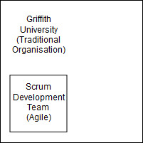

The generic structure of every project is that is starts with Initiation, followed by Planning, which feeds into Execution followed by Closure.

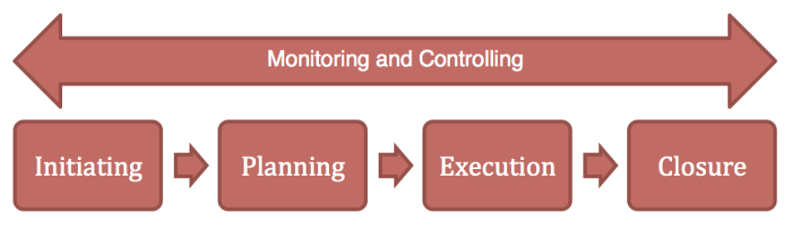

The project charter for this project is referred to as the *Project Proposal Document*, this is the document presented to the University to seek for formal authorization of a proposed project. After the potential project is assessed by the executive board of the University the *Project Initiation Document* is produced, this is the document that formally authorizes the existence of the project and provides the project manager with the authority to apply organizational resources to project activities.

The planning and execution of the project occurs at a sprint by sprint basis. As the nature of the project is agile this means detail focus is placed upon the sprint basis while using high level planning for the long term. In order for the agile project to continue to be endorsed by the university the project team must have accurate estimate margins for the long term in terms of scope time and cost management, using relative estimation, real options, expert judgement or any combination of the mentioned to retain the University institutions ongoing support.

After the university has established the baselines with respect to time, cost and schedule the team will perform in the agile flavour chosen, which is a combination of Scrum and Kanban. The project team must develop contingency reserves to remain within the baselines defined by the University.

The Planning and Execution phases of the project occur cyclically in the each agile sprint. For an agile team to perform in a traditionally bureaucratic oriented institution the team must remain within the schedule, cost, and scope requirements agreed with or set by the University, unless any formal change request is raised and granted the permission to make the change.

In the execution phase, the project team must operate within the limits of the triple constraints (i.e. Schedule, cost and scope) and deliver a minimum viable product that satisfies the needs of the stakeholder(s). While doing so the project team must consider Risk, Quality, Stakeholder, Communications, HR, Procurement and Integration management on a sprint by sprint basis.

--Scope--

The Project Management document’s perhaps most important key area is Scope Management, the scope is defined by the university’s Project Proposal Document (PID), The PID is consulted with Griffith executive team in conjunction with consulting the Portal and Apps team that looks directly after administering My Griffith. The core of the scope is established after the Project Proposal Document (PPD) is released, at this stage the scope is said to be validated. The fine details of the scope is established during the *Planning Scope Management* phase which is the release of the PPD. The next phase is to collect and analyse requirements which takes place with the initial requirements collection session with the Scrum master, the project owner and the business analyst, all requirements are collected and collated in the Product Backlog. Agile does not have a work break-down structure as the approach is adept in approaching change and uncertainty and promoting innovation. Scope control is a continual practice of making sure all procedures in every sprint align with the delivery of the defined scope in the PPD.

--Time--

Next is Schedule, Time Management cannot begin until the scope is defined. In an Agile team the delivery date is set, the team must adjust its team velocity and work with compromises in balancing between value, quality and the triple constraints. Time management starts with Planning schedule management, this acknowledges the total series of sprints must lie in the time span from project initiation to project closure. The next concept is the Activity Definition, this is the collection of all activities required to satisfy the product backlog, and this includes all the components relating to development, testing and design. The sum activities in all sprints must equal the total of defined activities in the Activity definition phase. This is followed by activity sequencing, this can be accomplished using the Product Roadmap, this is an effective tool in visually displaying the order and dependencies of activities, this toolkit can assist in determining the sequence serve as an aid to other areas of project management such as procurement management. The roadmap will reveal any side-by-side or parallel activities that may require procurement or hiring more staff.

Using the product roadmap in the activity sequencing, will reveal the dependencies as mentioned, the backlog of activities and the resources of the performing team will determine the output for the next step which is Activity Resource Estimation, this can be done using expert judgment if the agile team has reviews and retrospectives from previous projects. On the contrary the team can procure expert judgment in combination with running planning workshops before the sprints commence.

Following the Activity Resource Estimation is Activity Duration Estimation. The agile team can calculate the duration using the estimation point in the scrum release backlog with the team velocity to calculate the total number of sprints required [x1]. The advice of this folio is to factor-in a ten percent contingency schedule margin to compensate any spikes that may occur in the scrum project. Additionally using planning workshops and expert judgement is advised as agile is dependent upon reliable estimates and a competent team.

The next step is schedule development, after the revision of the project roadmap and the predicted number of sprints a Gantt chart can be developed. As the nature of this project is agile this gantt chart is not definitive, but only to be used as a guide for the team to keep track of schedule. Additionally this chart may include contingency schedule margins for management, but exclude these in the chart that the scrum team refers to, in order to promote productive eustress.

The final step of Time Management is Schedule Control, this is to be accomplished via reviews and retrospectives after each sprint. These findings with then be emphasised throughout the daily stand-ups as required.

--Cost Management—

Once the scope of the work to be delivered and the timeframe is determined the next knowledge area to address is Cost Management. The related steps in sequence to cost management is as follows: Planning cost management, Estimating Costs, Determining the Budget, and Controlling Costs.

Planning Cost management starts with determining the sponsors and the source of funds allocated to the Sam chat bot project, how much the executive committee is willing to allocate, the University is responsible for following a financially sustainable solution path as their Mission statement says:

“**To progress towards top performing finance function in the provision of accurate, transparent, relevant and timely decision making information and analysis.**”

This notion of financial responsibility in maintaining sustainable investments is further reinforces in the Universities Vision statement:

“**To be a value adding progressive business partner, while continuing to be stewards of financial sustainability across all aspects of the University.**”

The Planning Cost management is best accomplished by investigating the Real Options, and conducting real life estimation as this project is an entrepreneurial endear.

The next stage is estimating the actual cost of the project, after having identifies the possible tasks to complete in the course of satisfying the scope (remember this is an agile project) with built in contingency margins, these work estimations need to be compared with the available resources, available personnel including any outsourcing as part of the contingency (which will incur costs) and how much the human resources as well as the process cost needs to be determined. This is best accomplished with relative estimation based on similar past projects as well as expert advice in planned workshops, in this scenario the presence of the business analyst is vital in facilitating conceptual understanding of the work between investors, estimation experts and the technical team.

Determining the budget can be accomplished using the outcomes of the previous steps as input. This can be ratified by the financial department of the University.

After the Budget is determined the Agile team is responsible for controlling costs, this last step will be accomplished by the scrum team ensuring that each iteration cost are reasonable to leave the budget in surplus for the next iterations. Controlling costs requires reviews and retrospectives at the end of each iteration or release.

* Quality Management –

Quality is an intrinsic attribute, this means that quality is physically a non-tangible attribute nut rather a perceivable concept. Quality is an interpretation of the required benchmark for performance for physical characteristics in a product or service.

In other words, the focus of quality is the question “are we building the product right”, while the scope addresses the question of “are we building the right product.”

Quality management incorporates three steps, Planning Quality Management, Performing quality assurance and Controlling Quality.

The first step is Planning quality management, this means to elicit quality requirement s in the form of user stories, the are not user stories that state what the delivered functionality of a product should be, but rather how should the delivered functionality exhibit itself with respect to measurable output. This is setting quality goals, quality goals must be elicited from the stakeholders by the business analyst and conveyed to the development team in terms of measurable objectives. Quality goals are best expressed in term of user stories but can also feature as acceptance criteria in the story elaboration.

The next stage is Performing Quality Assurance, this involved enforcing quality assurance activities that address the quality goals. As quality is intrinsic, it is not easy to gather for this reason a planning workshop to brainstorm quality attributes and add to a checklist is necessary, for example combining release modules into a well-integrated final product is a quality attribute that only the development team can elicit.

The final step is quality controlling, this involves test cases on deliverables, ensuring test result satisfy the checklist of quality goals.

--- Risk Management –

As agile is concerned with delivering technology in a shorter period of time in iteration while responding to change, this brings about the topic of dealing with the unexpected. An agile team is meant to be somewhere on the spectrum of risk-neutral and risk-seeking, but cannot be risk-averse. Due to complex nature of software development and producing innovative solution via agile, a risk-averse attitude is not viable with the agile approach. Therefore risk management is most definitely an important part of an agile project.

The processes in risk management are as follows: Risk Management Planning, Risk Identification, Qualitative Risk Analysis, Quantitative Risk Analysis, Risk Response Planning, Risk Monitoring and Control.

Risk Management Planning is concerned with the methodology of identifying, dealing and monitoring the risk. For the project the proposed risk management strategy is to have a Risk register that addressed the duration of the life cycle of the project, each identified risk must be analysed and evaluated according to the risk matrix to determine the likelihood and consequence, and comment how it will affect the cost, scope, schedule and quality of the project. The risk register should be referred for each sprint and risks pertinent to that sprint should be identified. Each time a risk is identified or eliminated this should be noted to a central risk repository.

The next step is Risk Identification, this should be conducted before the scrum project begins and during every scrum meeting before the start of each sprint. Each identified risk must be noted with respect to its likelihood and potential impact. The strategy for avoiding and dealing with risks should also be tabulated. In this context avoiding risks means to decrease the likelihood and dealing with means reducing the impact of a risk that has been met with. The strategy to implement this is risk audits and a SWOT analysis for each tasks.

Qualitative Risk analysis involves analysing potential risks based on previous lessons learned, as qualitative implies a perceivable attribute through means of observation and measurement rather than a physically tangible attribute. Qualitative Risk analysis is best performed via consultation with experiences personal with planned workshops as this aspect relies on experience to foresee potential risks.

Quantitative risk analysis carries on the previous step, once potential risks are identified quantitative analysis deals with calculating the real impact of identified risks on the project. Again the likelihood and impact must be noted and each risk must be tracked.

The next step is Risk Response planning, this is concerned with the avoidance and mitigation techniques. These techniques need to be developed in focus groups and planning workshops, where even relative estimations with respect to projects of similar nature should be made. This procedure insures that the team can foresee an approaching risk or efficiently deal with a risk that has come to pass.

The last step of this knowledge area is Risk Monitoring and Control, throughout the project a dedicated team member should be responsible for identifying and specifying the top five risk to the entire project and to the particular sprint. A dedicated risk analyst in the team with ensure process efficiency and avoidance or minimisation of the impact of potential spikes in the scrum project.

--Stakeholder Management—

Stakeholder management is an important aspect of project manage, and perhaps one of the most challenging. A stakeholder is person who may be involved or affected by you project. Such people can have positive or negative effects depending on their level of power to influence the project.

Stakeholder management is concerned with managing you stakeholder in order to meet their expectations, maximise the potential of their support and minimise any potential negative influences from people with resistive views toward the project or any of its elements.

The stakeholder communication table above is a general summation of all possible stakeholders. The interaction with the type of stakeholders will vary throughout the scope of the project.

The stakeholder management process has four sub processes they are: Identifying Stakeholder, Planning Stakeholder, Managing Stakeholder, and Controlling Stakeholder Engagement.

Identifying stakeholders is concerned with identifying all people impacted by the project and /or has any involvement in the success of the project. This process is best implemented through initial consultations and planning workshops.

Planning Stakeholder Management is concerned with selecting the best strategy for both engaging and managing stakeholders across the project stakeholders. This folio proposes two different strategies, one for the key stakeholders and one for the end users of the Sam bot system.

The strategy for the key stakeholders that is executives of Griffith and the development team is to hold focus groups to gather expectation of management. The strategy for end users is to conduct online, on campus surveys and map the results into personas and Kano analysis, the result of the Kano analysis can be fed into a purpose alignment model to target development to the business goals mentioned above, these include increase the goodwill of the university, and provide an effective platform for advisement.

After the above two processes are completed, these feed as inputs the next stage, Managing Stakeholder Engagement. Managing stakeholder engagement deals with using the Stakeholder Communication table in this folio effectively influence stakeholder expectations to gather stakeholder support towards the completion of the project, this is best done by the team perpetually reinforcing the Vision statement. Part of this process includes incorporating the finding of the Purpose alignment model in the previous step to incorporate findings into the system design.

The last step of this process is Controlling Stakeholder Engagement, this sub process deals with managing the needs and expectations of project stakeholders in order to promote the vision statement and resolve issues. The recommendations in this folio is to include key stakeholders in the initial meetings of every sprint. Using feedback of stakeholders, the scrum team needs to conduct reviews and retrospectives and thus incorporate their findings into their development work. The business analysts’ involvement in liaising the Stakeholder management is critical for effective communication, which is the next knowledge area to be discussed.

-- Communications Management –

Project Success requires effective coordination, this depends on organisation and organisation relies on communication. Therefore the key to successful Stakeholder management is an effective communication plan.

Communication is the art of getting the right information to the right people at the right time. A common challenge in IT is to have IT professionals to be able to communicate with a broad spectrum of people besides other IT professional.

The processes involved with Communication Management are: Planning Communications Management, Managing Communications and Controlling Communications.

Planning communications management is the process of determining the necessary flow of information and communication to the stakeholders. The most effective strategy this folio can advise is to refer to the stakeholder communication table above and expand it to add columns that include at which stage of the projects communications will take place and to what extent, indicated using ordinal symbols.

This phase also needs to consider the communication needs as well as mechanism of communication for each associated stakeholder of each stage of the project. The best way to establish this is to use planning workshops at the very beginning of the project before the project commences.

Managing Communications deals with the steps involved with communications from initial setup to final disposal. Ensuring stakeholder and development team have the mechanism to communicate and the skills to do so is crucial. This means the Business Analyst of the development team may need to run workshops with the development team to inform the team in methods of communication and establishing rapport with clients and sub-contractors. As the frequency of communications, the subjects of the communication and the nature of content of communication is likely to change due to the progression of the project it is important to effectively manage communications.

The final process for this knowledge area is Controlling Communications, this is to make sure that the two processes above are managed effectively as prescribed. The strategy for this is to elicit feedback from stakeholders external to the scrum development team. The feedback is to be discussed between the business analyst and the scrum master, their findings, recommendations is then to be delivered to the development team in the daily stand-up session.

The remaining knowledge areas with respect to project management include Human resource management, procurement management and integration management.

X1 - https://www.scrum-institute.org/Release_Planning.php

## APM Framework

Describe your application of the APM Framework

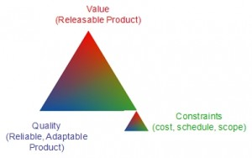

**References:**

[1] Dr. Larry Wen (2017). [*"Lecture_1_Introduction"*](http://www.research.ibm.com/software/IBMResearch/multimedia/Computing_Cognition_WhitePaper.pdf) (PDF). Griffith University: *Software Architecture*

[2] <http://www.professionalqa.com/agile-vs-traditional-development>

[3] Dr. John (2015). [*"Computing, cognition and the future of knowing"*](http://www.research.ibm.com/software/IBMResearch/multimedia/Computing_Cognition_WhitePaper.pdf) (PDF). IBM Research: Cognitive Computing. IBM Corporation